2024-2025

Transportation Information Manual

For

Families and Students

Addison Central School District

C:\Program Files\Microsoft Office\MEDIA\CAGCAT10\j0183328.wmf

It’s the LAW:

STOP FOR LOADING AND UNLOADING OF SCHOOL BUSES.

When you stop for a school bus, **you cannot drive again** until the red lights stop flashing or when the bus driver or a traffic officer signals then you can proceed. This law applies on all roadways in New York State. You must stop for a school bus even if it is on the opposite side of a divided highway.

Definition of a “Public highway” is a road that is used for parking of motor vehicles or used as a driveway located on the grounds of a school or a Board of Cooperative Educational Services (BOCES) facility or any area used as a means of access to and egress from such school or facility (V&T Section 1176).

**FOREWORD**

Approximately 1,100 students residing in the Addison Central School district have the opportunity to be bused to our schools: Valley Early Childhood Pre-K, Tuscarora Elementary and the Addison Middle/High School.

The policies of the ACSD Board of Education, the rules and regulations of New York State, and our operating guidelines, establish the framework for our student transportation system. This manual is designed to help students, families, and school personnel have a clear understanding of the policies and guidelines under which we operate and communicate bus safety protocols. Communicating and working together will help promote understanding and help create a safe bus riding experience to and from our schools.

Please feel free to call the Addison Central School District Transportation Office if you have any concerns or questions about the information in this manual.

**Addison Central School District Telephone Numbers**

**Transportation Department……….. 359-2415**

**District Office ……………………………. 359-2244**

**Business Office ……………………….... 359-2245**

**Middle/High School ……… 359-2241**

**Tuscarora Elementary School …….. 359-2261**

**Valley Early Childhood Pre-K……… 695-2636**

**The school bus in an extension of the school; therefore, students are expected to follow the ACSD Code of Conduct while on the bus.**

**General Guidelines:**

* Designated stops for all students will be set under safe conditions and shall be approved by the Transportation Department.
* Stops will be reviewed annually by the Transportation Department.
* Routes may be extended, shortened or altered at any time to accommodate changes in population, state laws, or due to safety concerns. Buses will not travel roads that are private, have restricted traffic flow, are not maintained by the appropriate highway department or when conditions are judged to be unsafe for student transportation. Such determination will be the responsibility of the Transportation Supervisor. Bus Drivers shall stop at designated bus stops only. Drivers shall use good judgment if an incident dictates a temporary exemption.
* All turnarounds must be approved by the Transportation Supervisor.

**INFORMATION FOR OUR FAMILIES AND CAREGIVERS:**

**FAMILY RESPONSIBILITIES**

Families play an important role in the safe and efficient operation of the school’s transportation system by supporting and teaching their children of proper bus protocols.

Families are required to provide a **Daily Transportation Plan** for each student by July 1st each year, on a form provided by the school. This is the daily plan that will be followed for the student. These forms can be downloaded using the links below:

[Daily Transportation Plan - 2024-2025.pdf](C:\\Users\\leldridge\\OneDrive - GST BOCES\\Daily Transportation Plan - 2023-2024.pdf)

***Daily transportation changes will not be accepted. There will be no exceptions.***

*Any* ***EMERGENCY*** *transportation situation must be communicated to the Main Office of your child’s school by phone call only.*

If your student has a permanent change in their transportation plan, a new form must be re-submitted to the Main Office of the school your student attends.

**REVIEW THE FOLLOWING SAFETY RULES WITH YOUR CHILD:**

* Stay away from the Danger Zones around the bus.
* Do not try to pick up something dropped near the bus. Inform the bus driver and ask for assistance.
* Remember: other motorists don’t always stop for a stopped school bus-use extreme caution when getting on or off bus and while crossing.
* Always watch driver for the universal cross signal to cross the street.

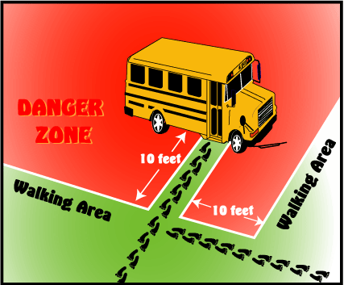

**AT THE BUS STOP**

* Families are responsible for assisting children to get to the stop and home from the stop. Students will report to their bus stop at least five minutes prior to scheduled pickup time.  Drivers cannot wait for students who are not on-time.
* Students will wait 10 FEET OR MORE away from the roadway and remain there until the bus comes to a COMPLETE STOP. Wait until the bus has stopped completely and the driver has opened the door and signaled to board the bus.

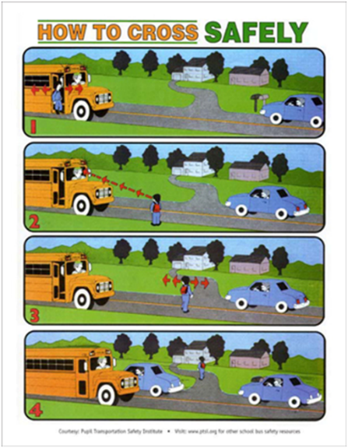

* Students will observe all safety precautions while waiting for the bus.
* Wait for the bus to arrive and the driver to instruct you to cross with the universal signal.
* Keep hands, feet and other objects to yourself (KHFOOTY)
* Avoid horse play at the bus stop

**LOADING THE BUS**

* Students who cross the road should be 10 feet in front of the bus and will wait for the universal crossing signal (S.E.D.156.3 hi).
* Students will use the handrail when boarding the bus.
* Students will board the bus quickly, quietly, and in an orderly fashion, and sit in their assigned seat.
* Students will listen carefully and follow instructions given by bus personnel.
* Students will remain on the bus until either they arrive at school, a specific destination, or an assigned stop.
* Students will not board with any object that is potentially dangerous or distracting to other students or bus personnel, nor with any object which cannot be held safely on their lap.

**RIDING THE BUS:  “Seat to seat, back to back, buckle up”**

* Students will be courteous to other students and bus personnel.
* Students will use appropriate language at all times when on the bus.
* Students will keep hands, feet and other objects to yourself (KHFOOTY).
* Students will remain seated at all times while on the bus.

**UNLOADING THE BUS**

* Students will look both ways before stepping off of the bus.
* Students will exit the bus; wait to be signaled by the driver, and then cross ten feet in front of the bus.  Students will stop at the center of the roadway and look both ways before continuing to cross (S.E.D. 156.3 h-i).
* Students will leave the bus in an orderly and courteous manner.  Non-crossers will exit the bus and go directly to the sidewalk, driveway, or a safe area away from the bus.
* Students will not cross behind the bus at any time.
* Students will wait until the bus departs to collect mail or complete other assigned household tasks.

**Afternoon Bus Drop-Off for Grades Pre-K through 5th Grade:**

* A family/guardian must be home, come to the door, and be seen by the driver before a student can be released from the bus. *This applies to all students up through5th grade*.
* If the family/guardian will not be home, please designate a person to receive your child. This person must be on your child’s SchoolTool list as having approved pick-up rights.
* If the student cannot be released from the bus because there is not an authorized adult present, the student will be returned to the Tuscarora Main Office as soon as possible. The family/guardian will be contacted to pick up the child at the school.

**MORNING DROP-OFF/AFTERNOON PICK-UP (BY PROGRAM)**

**Valley Early Childhood Pre-K:**

**Morning Drop-Off (AM):**

* The Valley School building will be open for student drop-off from 7:30-8:15am.
* Vehicles dropping off children will line up single file curbside in front of the school. Children will be walked to the main door where a staff member will escort him/her to the correct location.
* The bus loop will close for cars at 8:15am for bus arrival.

**Afternoon Pick-Up (PM):**

* Afternoon pick-up at Valley will run from approximately 1:30-1:40pm and will begin as soon as the busses are loaded and depart from the front of the building.
* Vehicles picking up children will line up single file curbside in front of the school. Children will be escorted to their individual vehicles by school staff.
* If you arrive for pick-up prior to the busses arriving at the school, please wait to enter the parking lot/bus loop until the busses have arrived and children are exiting the building.

**\*NOTE- For everyone’s safety, DO NOT pass vehicles as they are dropping off or picking up students*.**

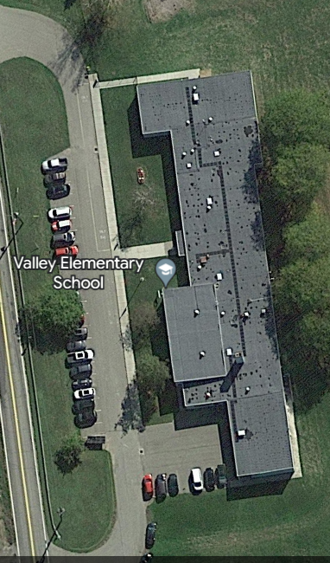

Valley Early Childhood Pre-K

**Tuscarora Elementary:**

**Morning Drop-Off (AM):**

* Morning drop-off begins at 7:30 AM. Students may *not* be dropped off prior to 7:30 AM.
* Vehicles will enter the ***District Office*** loop and drop off students at District Office door (Exit 1). Staff will be available to greet students entering the building at 7:30 AM.

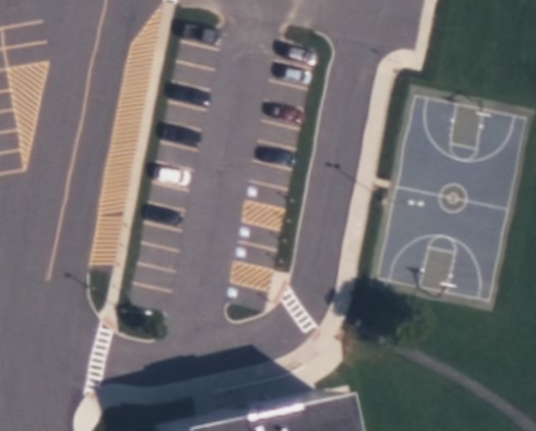

Addison District Office

**Afternoon Pick-Up (PM):**

* Afternoon pick-up is 2:40-2:55 daily (gate will be raised once the last bus leaves the Tuscarora campus).
* Vehicles will enter the ***Bus Loop*** in front of Tuscarora Elementary School. This is ONE LANE ONLY.
* Families will remain in their cars and identity will be confirmed by staff at vehicle. Once identity has been confirmed, student will be released from the supervision location to families by the afternoon dismissal team. Students will exit the building through the Exit 6 (between Library and Cafeteria).
* For safety purposes, all cars in the loop are to remain in their order of arrival/entry.

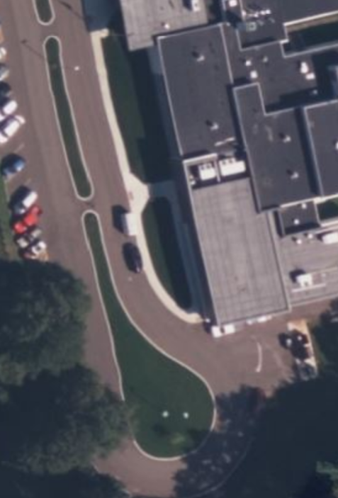

Tuscarora Bus Loop-Exit 6-Library

**Middle/High School:**

**Morning Drop Off/Afternoon Pick Up (AM & PM):**

* The Middle – High School building opens at 7:30AM.  For student safety, please avoid dropping off before 7:30AM as there is no supervision for your child.  Afternoon pick up is at dismissal, which is 2:50PM
* Also for student safety, families are not permitted to drive on Colwell in front of the middle school in order to protect students who are crossing the street.
* Families should use Valerio and Wombaugh Streets to exit the school area.
* Middle school students enter the building through the Middle School ramp.
* High school students enter the building through Entrance #1, by the pillars or at the Event Center doors.
* Option 1 for Drop off/Pick up: (Figure 1)
  + Vehicles will enter the family drop off zone, which is in front of the pillar entrance (entrance #1).
  + After dropping your child off, please use Valerio street and exit at the light.
* Option 2 for Drop off/Pick up: (Figure 2)
  + Vehicles will enter parking lot E by Wombaugh Street, and students will cross Colwell Steet using the crosswalk areas.
  + After dropping your child off, please exit using Wombaugh Street.

**Figure 1 (Option 1) Figure 2 (Option 2)**

**ARTICLES CARRIED ON SCHOOL BUSES**

**Department of Transportation Regulations**

At no time shall any article protrude into the aisle or walkway where it interferes with the safety of students. Nor shall any article block the emergency door or windows (D.O.T. 721.22). Any article that cannot be safely carried on the student’s lap cannot be transported to school on a school bus. Drivers do not carry ropes or straps to secure articles too large or too dangerous to hold in the lap.

**ITEMS NOT TO BE TRANSPORTED TO OR FROM SCHOOL ON THE BUS:**

Weapons:Knives, sharp objects, glass products, bow and arrows, guns, etc.

Athletic Equipment:Hockey sticks, ski poles, skis, golf clubs, fishing poles, scooters, skateboards, etc.

Dangerous or distracting Items/Substances: Chemicals, flammable liquids, aerosol containers, perfume products, drugs (legal or illegal), noisemakers, lasers, balloons, lighters, etc.

Excessively Large Objects: Large school projects, musical instruments (baritone horn, cello, tuba, percussion cases), etc.

Live Animals: No live animals, bugs, reptiles or fish of any kind.

The bus driver reserves the right to refuse any object/substance not covered on this list.

**STUDENT RESPONSIBILITIES AND BUS SAFETY GUIDELINES**

1. It is the expectation that students will comply with verbal requests made by the bus driver, monitor, and/or district personnel.
2. Students will keep all body parts and belongings inside the bus at all times. Students will not throw anything in, out of, or at a bus or any other vehicle.
3. Drink, food or candy is not permitted on regular bus routes.
4. There is ABSOLUTELY NO SMOKING, VAPING, CHEWING OR POSSESSION OF TOBACCO OR MARIJUANA PRODUCTS on or near the school bus at any time.
5. Students transferring buses must go directly to their transfer bus.
6. Students will get on and off the bus at their regularly designated stop.
7. Students who are found to have violated the district’s Code of Conduct while riding the bus may be subject to suspension from transportation. In such cases, the student’s family will become responsible for getting their child to and from school safely.

**EXPECTATIONS FOR POSITIVE BEHAVIOR WHILE RIDING THE SCHOOL BUS:**

The school bus is an extension of the school and students are expected to follow the ACSD Code of Conduct while on the bus.

Interventions for students who are not abiding by the district Code of Conduct include:

1. Verbal warnings by the driver, monitor or transportation personnel.
2. Change of seat.
3. One on one conversation with transportation personnel at the conclusion of the ride.
4. Discipline referral (as per ACSD Code of Conduct)

**ADDITIONAL TRANSPORTATION INFORMATION**

**BABYSITTERS AND DAY CARE CENTERS**

Students will be transported to approved day care centers, private day care and Latch Key locations within the district. The location must be on a regular bus route where students can be dropped off at an approved bus stop location. The request must be included on the Daily Transportation form.

**BUS LOAD CAPACITIES**

Buses are loaded as near to capacity as possible, taking into consideration distance, time and locations of schools. The large buses are approved to transport 65 children.

**EARLY DISMISSAL / HALF DAY RELEASE FOR K-12**

Please check the school calendar for release times and dates. Students will arrive at their drop-off location indicated on the Daily Transportation plan.

**ELECTRONIC DEVICES**

Cell phones will be permitted for use on the bus, provided their use does not result in a distraction for others. Cell phones with camera capabilities are not to be used on the bus to avoid distracting the bus driver.

**EMERGENCY DISMISSAL**

The **Emergency School Closing Plan,** which is sent home to each family must be accurate and up to date.  If children are sent home due to an emergency closing, these directions will be followed EXACTLY as written.  **We are not able to call individual families.**  If the form is not completed, we will send the child home on his/her regular bus.   Latch Key, AYC Littles and the Addison Youth Center are closed in the event of an early dismissal. This required form can be downloaded using the link below:

[Emergency School Closing Plan 2024-2025.docx](https://gstbocessscta-my.sharepoint.com/:w:/g/personal/gweed_gstboces_org/EbMggIcbL01BghMrENH5pk8Bjkb-B9ACa2tZ_u58Ho0_WQ?e=7FjPnl)

**EMERGENCY DRILLS**

The New York State Department of Education (Reg.156.3) requires that at least three bus emergency drills be conducted each year. The procedure for students to follow in case of an accident, including how to properly use the emergency exit windows and doors, will be covered. There may be additional drills held at each school during the year. Students assigned to help during these drills are expected to follow protocols for the safety of all students.

**PRIVATE SCHOOLS**

A family desiring transportation for his or her child to a nonpublic school must submit a request to the public school district by April first preceding the school year or within thirty days after establishing residence in the district. Late requests may not be denied where there is no additional cost to provide the service. A board may refuse to grant a late transportation request where additional expenses and new transportation arrangements would be necessary. The request must be renewed annually (every year).

**SCHOOL CLOSINGS**

When an emergency makes it necessary to close school, an announcement will be broadcast on the school website, local radio and television stations and the district Facebook page shortly after 6:30 a.m. Generally, when schools are closed, all activities and events scheduled for that day and evening are cancelled.

**VIDEO CAMERAS**

Video cameras are being used regularly on district buses and help promote positive behavior. Families/Guardians are responsible for the conduct of their child on the bus. Video may be reviewed by school personnel in the event of inappropriate bus behavior and appropriate consequences assessed for infractions. Progressive consequences may be assigned, including bus suspensions, according to the ACSD Code of Conduct. Video recording occurs on all district buses, barring equipment failure/repairs.

**DELAYED START**

Winter weather conditions may warrant school delays by one to two hours. If this situation occurs, an announcement will be made on the radio and TV stations and the ACSD Facebook page. Please do not drop off a child or allow a child to walk to school early. The schools will be locked and supervision will not be available.

**A DELAY MEANS:**

Children report to bus pick up spots one to two hours later than the usual pick-up time (i.e.: 7:00am normal pick up; 2 hour delay means 9:00am pick up). Return home will be at the regular time, unless altered by the district and/or weather conditions.

Please do not call school personnel or the transportation department when schools are closed.

**GUIDELINES FOR ATHLETIC & EXTRACURRICULAR TRIPS**

**Students representing the district on an athletic or extracurricular trip must conduct themselves respectfully, responsibly, and safely.**

* Eating on athletic trips is occasionally permitted, provided it is done in a neat and orderly fashion. NO GLASS BOTTLES are allowed. On trips, food is up to the discretion of the driver.
* Sharp objects such as skis and ski poles are not permitted on the bus. Other equipment, luggage, etc., must be strapped in and securely anchored. Items must be stored so they do not interfere with the driver’s vision, block the aisle, or interfere with the safety of the students.
* Athletic shoes with metal spikes/cleats must not be worn on the bus.
* Adults and students are responsible for checking for items as they leave the bus and picking up after themselves at the end of a trip.